How do I access Canvas:
GCCC Students and Faculty can log on by visiting: GCCC Canvas Sign-on. This will automatically go to GCCCs single sign-on system (SSO). You can also access Canvas from the Student Canvas Page on the GCCC website: Canvas Login.
NOTE: Once you get to the login page, we suggest you bookmark it or add it to your Favorites, so it is easily accessible in the future!

Steps to Log In to Canvas:
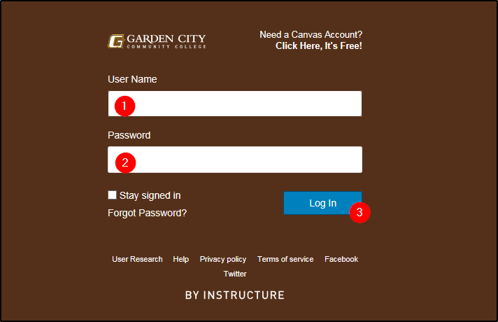
1) Enter your GCCC network ID credentials. This will be your first.last name.
2) Enter your GCCC network password. Your Password is the first initial of your first name (lowercase), the first initial of your last name (uppercase) and your birthdate (8 digits) in the MMDDYYYY format (i.e., if your name is ‘John Doe’ and your DOB is March 20, 1985, your password is jD03201985).
3) Click “Log in”.
If you have questions about your BusterMail account, click here for help: BusterMail

Inside Canvas: the Dashboard
You are now inside the Canvas Dashboard. All enrolled courses should be visible on the Dashboard.
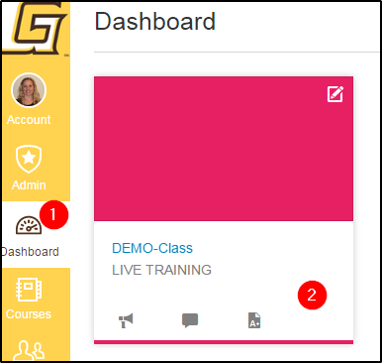
1) Click on Dashboard to see classes.
2) Click on class tile to open course.

Inside the Course: This is the Home Page
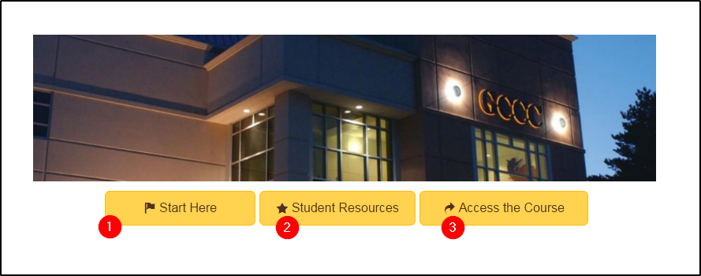

1) Click “Start Here” to see textbook information, faculty bio, and more.
2) “Student Resources” provides an over view video of Canvas, Canvas Help Guides, tech requirements, Frequently Asked Questions, and more.
3) Click “Access the Course” when you are ready to begin working/exploring in your class.

