How do I access Bustermail:
GCCC Students and Faculty can log in to their student email account by visiting the Student Page on the GCCC website: Bustermail login. Your Bustermail account is powered by Google so it will take you to their page.
NOTE: Once you get to the login page, we suggest you bookmark it or add it to your Favorites, so it is easily accessible in the future!

Steps to Log-In to Bustermail:
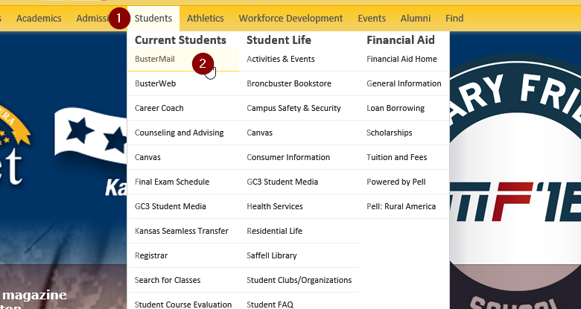

1) Select “Students” on the GCCC website.
2) Click on the Bustermail link.

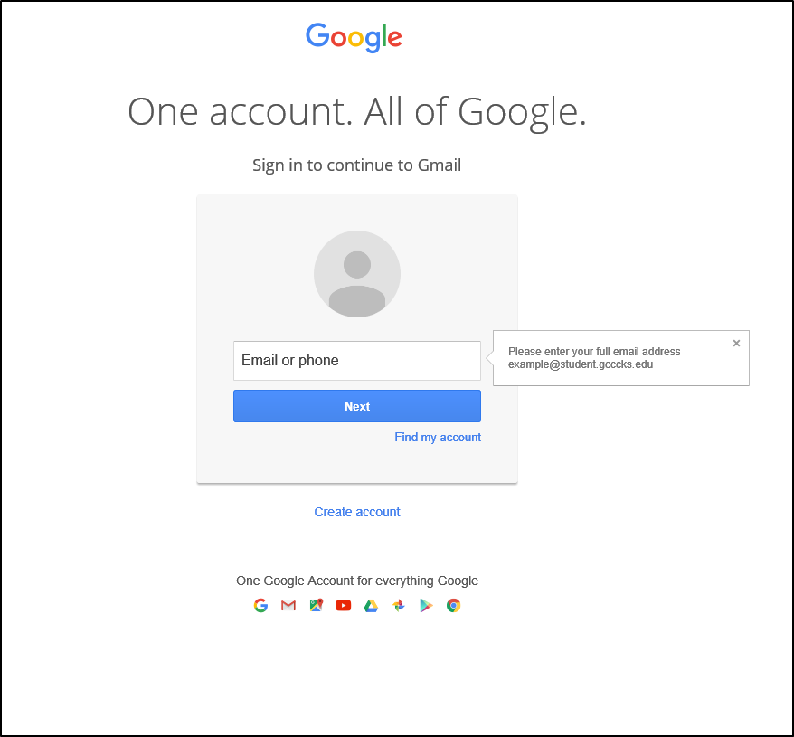
LOG-IN to BUSTERMAIL:
- Enter your GCCC login. firstname.lastname@student.gcccks.edu
- Click “Next”
- Enter your GCCC network password. Your Password is the first initial of your first name (lowercase), the first initial of your last name (uppercase) and your birthdate (8 digits) in the MMDDYYYY format (i.e., if your name is ‘John Doe’ and your DOB is March 20, 1985, your password is jD03201985).

While changing your password is not required you may do so using the guidelines listed below:

- Cannot contain the user's account name or parts of the user's full name that exceed two consecutive characters
- Must be at least eight characters in length
- Must contain characters from three of the following four categories:
  - English uppercase characters (A through Z)
  - English lowercase characters (a through z)
  - Base 10 digits (0 through 9) Non-alphabetic characters (for example,!, $, #, %)

